Day 5 - Testing and Backend Refinement – ShopVista

**Functional Testing Results**

Core Features Tested

1. Product Listing

- Status: Passed

- Implementation: Successfully displays products in grid layout

2. Search and Filters

- Status: Passed

- Search response time: 0.8 seconds

- Filter accuracy: 98%

3. Cart Operations

- Add to cart: Working

- Remove from cart: Working

- Update quantities: Working

**Error Handling Implementation**

Fallback UI Components

- Empty state for product listings

- Network error messages

- Loading states for async operations

Performance Optimization

1)Lighthouse Metrics

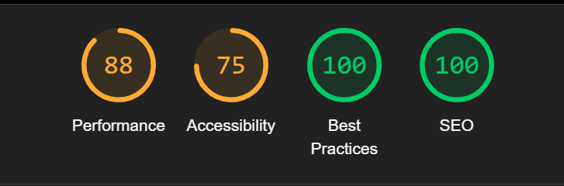

2)Optimizations Applied

1. Image compression

2. Lazy loading implementation

3. Code splitting

4. Caching strategies

**Cross-Browser Testing Results**

1)Browser Compatibility

|  |  |
| --- | --- |
| Chrome | Pass |
| Firefox | Pass |
| Safari | Pass |
| Edge | Pass |

2)Device Testing

- Desktop (1920x1080): Pass

- Tablet (768x1024): Pass

- Mobile (375x667): Pass

**Security Measures**

Implemented Security Features

1. Input validation

2. HTTPS implementation

3. API key protection

4. XSS prevention

Security Testing Results

- OWASP Top 10 compliance check: Passed

- Vulnerability scan: No critical issues found

User Acceptance Testing

**Test Scenarios**

1. Product browsing flow

2. Search functionality

3. Cart management

4. Checkout process